|  |  |  |  |
| --- | --- | --- | --- |
| **SVKM's-IOT, Dhule**Shri Vile Parle Kelavani Mandal's  **INSTITUTE OF TECHNOLOGY**  **DHULE (M.S.)**  **DEPARMENT OF COMPUTER ENGINEERING** | | | |
| **Subject :** Java Programming Lab | | | Remark |
| **Name :** Ansari Asharul Ameen Naeem Ahmad | | **Roll No. :** 63 |
| **Class :** SY. Comp. Engg. | **Batch :** S4 | **Division:** A |
| **Expt. No. :**01 | **Date :** 14/08/2024 | | Signature |
| **Title :** Write a Java Program to display a message. | | |
|  | | |
|  | | |

**CODE 1 : BASIC JAVA PROGRAM**

class Ashar{

public static void main(String[]args){

System.out.println("Welcome to java lab");

}

}

**OUTPUT :**

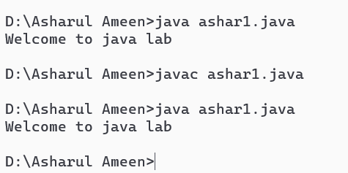

**CODE 2 : SWAPPING OF TWO NUMBERS**

public class swapping

{

public static void main(String[] args)

{

int x = 100, y = 200;

System.out.println("Before Swap");

System.out.println("x = " + x);

System.out.println("y = " + y);

int temp = x;

x = y;

y = temp;

System.out.println("After swap");

System.out.println("x = " + x);

System.out.println("y = " + y);

}

}

**OUTPUT :**

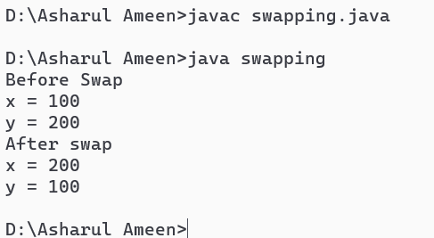

**CODE 3 :SWAPPING OF TWO NUMBERS USING INSTANCE VARIABLE**

public class SwapExample {

int a;

int b;

public SwapExample(int a, int b) {

this.a = a;

this.b = b;

}

public void swap() {

int temp = a;

a = b;

b = temp;

}

public void display() {

System.out.println("a = " + a + ", b = " + b);

}

public static void main(String[] args) {

SwapExample example = new SwapExample(5, 10);

System.out.println("Before swapping:");

example.display();

example.swap();

System.out.println("After swapping:");

example.display();

}

}

**OUTPUT :**

